**Moss Park Elementary**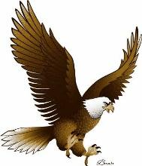

**Fourth Grade Supply List**

**2023 - 2024**

**Please label these items with your child’s name:**

1 – Pair of headphones or earbuds (kept at school)

1 – 3 Ring Pencil Pouch (slim)

1 – 1 1/2 inch “D” ring binder w/ clear plastic cover and inside front & back pockets

4 - **Plastic** folders with prongs and pockets: 1 blue, 1 green, 1 red, 1 purple

1 – 3 Subject Wide Ruled Spiral Notebook

1 - **Plastic** subject dividers w/pockets (5 subjects-ELA, Writing, Math, Science, Social Studies)

1 - Plastic pencil box

**Please do NOT label these items:**

4 packs of 24 **sharpened** #2 pencils

1 pack pencil cap erasers (24 count)

1 box of colored pencils

1 pair of scissors

2 glue sticks

2 packs of 8 dry erase markers (**Black** Expo Preferred)

2 boxes of tissues

1 bottle of hand sanitizer

1 bottle of liquid soap

1 Clorox Wipes

**Option Items:**

Wireless Mouse (chargeable)

Laptop protective sleeve (highly recommended)

**Boys Girls**

1 box of bandages 1 pack of 25 page protectors

1 pack Notebook paper 1 package highlighters